The | JOURNAL for  DRAMA in  EDUCATION
Volume 35, Issue 2
Autumn 2021
ISSN 1476 – 9395
Special Issue to accompany the International Conference:
Dorothy Heathcote Now, 8th – 10th October 2021

- Editorial
- Chair’s Report
- Man in a mess: person in a paradox, person in a paradigm,
person with a problem, person in a pandemic…
Sorrel Oates
- Shaving heads: Informing our total existence
Guy Williams
- ‘Why can’t every teacher use Mantle of the Expert?’
Renee Downey
- The Conventions of Dramatic Action: A Guide
Tim Taylor
Illustrated by Jim Kavanagh
- Signalling Across Space and Time:
Conventions of Dramatic Action and the Teacher’s Interpretation
Maggie Hulson

Rolling Role - a perspective

Claire Armstrong-Mills
- The Commissioners
Lisa Hinton
- The Dorothy Heathcote Archive
David Allen, Sandra Hesten and Stig A. Eriksson
- A précis of: Contexts for Active Learning:
Four models to forge links between schooling and society
Dorothy Heathcote
Précis by Guy Williams
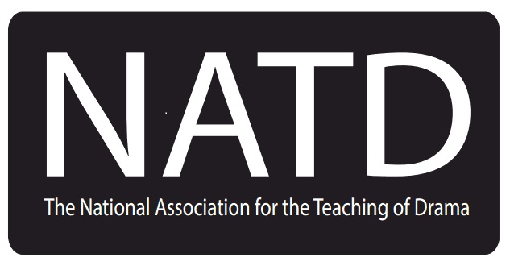 Charity Number 1135457

Editorial

That Dorothy Heathcote formulated significant contributions to education methodology is beyond question. Both in her work with teachers and in her writings, Dorothy’s impact on classroom practice and on teachers understanding of it has been profound.

It has been of great interest to us that in the wake of the societal upheavals of the past two years, there has been a re-awakening of interest in Heathcote’s work and of the humanising pedagogy she advocated. We are very happy to be publishing this issue of The Journal for Drama in Education as a companion piece to the Dorothy Heathcote Now: International Conference 8-10 October 2021.

It could be argued that this is a key generational moment. Although Dorothy herself died in 2011, there are many practitioners at present in the UK and around the world who worked with her, who took on and developed and broadcast her work. Some of them have contributed articles to this issue. What we do now matters. What we have learnt from her, what her body of work has to offer us now can enable us to remodel what happens in our classrooms so that we don’t return to the old ways, the old normal, that gave rise to the neglectful chaos we have been trying to live through.

The backbone of this issue is Dorothy’s original article Contexts for Active Learning. Four models to forge links between schooling and society, which she wrote following a presentation of it that she made to the NATD conference, Gradgrind’s Children, in 1998. In this article, Heathcote interrogated the world of contexts as a learning tool, describing four stages in her theory and practice. This description changed our understanding of how children learn and of how we can use drama as a learning tool.

Further below, we offer a précis of the whole article. (If you haven’t had the opportunity to read the original, we recommend that you do. It is available in Volume 19, Issue 1 and was reprinted in the Commemorative Issue Volume 28, Issue 3.) In the first instance, as we introduce each of the articles in this issue, we offer a list of the contexts:

Model 1 – Drama used to explore people
Model 2 – Mantle of the Expert
Model 3 – Rolling Role
Model 4 – The Commission Model

Model 1 – Drama used to explore people

In Man in a mess: person in a paradox, person in a paradigm, person with a problem, person in a pandemic… Sorrel Oates gives an account of why Heathcote’s influence is still so powerful today. She describes the political context within which she has to work and the journey she has been on to rediscover the principles that established her as such a formidable practitioner in the early 1990s as she emerged from David Davis’ PGCE (Postgraduate Certificate of Education) course at The University of Central England (UCE). Indeed, she very clearly describes Education in a mess and Society in a mess. Her solution has been to gather like-minded colleagues around her, in a progressive school and go back to highly complex basics. She eschews the artificial divide that has bedevilled Drama in Education for several decades and celebrates the essential relationship between Process Drama and the Art Form of Theatre. She teases out the key elements of Process Drama as invented by Heathcote; articulates the centrality of the crucible paradigm; and champions Heathcote’s ‘Levels of Meaning’ as the bedrock of her work. In this powerful opening piece, Oates concludes by placing the central, humanising demand:

Do they stand and watch or do they intervene? Like Edward Bond, Dorothy’s ‘man in a mess’ demands that we take a position, that we ask that question.

Guy Williams’ Shaving Heads: Informing our total existence opens with the stimulating act of shaving their heads by his students at a performance in August 2010, Mostar in Bosnia. This visceral act of ‘coming of age’ signalled to Williams that his educative ‘journey with them was over’. Williams reflects on his own practice of teaching Theatre Studies which was carved out by Heathcote’s models, especially that of ‘living through’ drama Model 1. He further studied her theory and practice during his MA programme at the University of Birmingham facilitated by David Davis. Williams works through the art form of theatre to the point where his students preferred to ‘provoke and communicate’, ‘rather than be looked at’.

The teacher-student dynamic is a central thread in his work with ‘man in a mess’, built on negotiation, the forging of bonds, responsiveness, the inversion of status. His work with students exploring the personal in the political is challenging, sometimes seen as controversial and always contextualised in the contemporary. The ‘shaving of heads’ is a symbolic, political, theatrical act. Yet, as Williams writes:

.. I never taught them to act… I am a teacher looking to make meaning and make sense of the world with young people.

Model 2 – Mantle of the Expert

In Why Can’t Every Teacher Use Mantle of the Expert? Renee Downey shows us how she became a keen advocate of Mantle of the Expert. From day two of her MA course through to reviewing the clear learning benefits for her own pupils some years later, Downey charts a learning journey for herself and her pupils that leaves us in no doubt of the educational force that is Mantle of the Expert. She offers us detail of her first tentative steps with her class, as well as analytical illustration of its long-term impact, and concludes with an inspirational account of her next steps as she moves on to advocate Mantle of the Expert in a wider sphere. She concludes that:

I’m a different kind of teacher, a researcher and a member of a strong teaching community.

As Heathcote was developing her models, she was also developing guidelines for classroom practice. One such set of guidelines is her conventions of dramatic action. Tim Taylor’s The Conventions of Dramatic Action – A Guide continues to develop his highly regarded craft and art of enabling and encouraging teachers in the application of Heathcote’s methodology to classroom practice. Heathcote’s conventions were first published in 1982 in her article ‘Signs (and Portents?)’ and they have appeared in a variety of settings since then. Essentially, Heathcote listed the conventions, each with a definition underneath. What Taylor does, supported by Jim Kavanagh’s convivial, credible illustrations, is to provide expanded models for each convention. He offers user-friendly detail, clearly grounded in classroom practice. As Taylor says:

Learning to use (the conventions) takes time and practice, but just as it is the artist, not the colours or the brushes, who creates the art, so it is the user of the conventions who creates the dramatic action.

Taylor’s guide shines with a human-centred method that challenges the child and locates the teacher as an artist in her classroom.

MaggieHulson’s Conventions of Dramatic Action and Teacher Use of Sign is a companion piece to Tim Taylor’s The Conventions of Dramatic Action: A Guide. Reading the two pieces side by side is an illuminating experience. Where Taylor has unpacked Heathcote’s conventions and focussed on what the students are doing, Hulson shifts the focus to the role of the teacher and her assistant. She uses more than eight concrete examples of what the adults in the room might be doing in order to facilitate the engagement and investment of the young people. She says of the Conventions that they can be ‘deceptively simple’ and argues for a sophisticated reading and application of them. They are not, ‘…goods that can easily be popped into a bag of teaching techniques…’ by time-poor teachers. By focussing on the teacher’s use of gesture, she highlights the richness and complexity of the process in which young people can bathe. She says that:

…the aim is twofold: to illustrate something of the pathway decisions a teacher might make in the moment to moment unfolding of the lesson; and to encourage the teacher to apply it.

Deceptively simple in its own right, this article is a wonderful exploration born of decades of practice both in the classroom and in educating teachers by an exceptional practitioner.

Model 3 – Rolling Role

Rolling Role is perhaps the least practised of the four contexts. Thus Claire Armstrong Mills’ article Rolling Role- A Perspective is a rare resource. Armstrong Mills’ aim is to encourage teachers to use her examples for themselves. She elucidates something of the theory behind Model 3 as she recounts her extensive contact with Dorothy Heathcote, including work on videos. Quoting Heathcote, Armstrong Mills explains that with Rolling Role:

…any number of members of staff can form teams of collaboration whilst teaching their own timetable and curriculum area.

As with other Models, the creation of a team and a context is central, with the careful formation of the human element of the community being essential, and this article furnishes us with details of one particular project. Armstrong Mills explains how teachers from a range of specialist subjects were able to opt into the project and how some were involved in planning with Heathcote. She describes the underpinning method and illustrates some of the lessons that arose, at the same time paying attention to learning theory. The article concludes with an analysis of why Rolling Role isn’t more widely practised and urges teachers to ‘…try ‘standing on the shoulders of a giant.’ I did, and the perspective was remarkable’.

Model 4 – The Commission Model

The classroom practice of Woodrow First School in Redditch is at the centre of Lisa Hinton’s The Commissioners. Describing the development of Model 4 work, Hinton coherently signposts the important differences between the Commission Model and that of the Mantle of the Expert, as well as the challenges faced by the teacher. She begins by describing how Mantle of the Expert was introduced to, and quickly embraced by, the staff at Woodrow. It laid the ground for new partnerships, new endeavours and influences and Hinton goes on to explain how a Commission was developed between her class and the Black Country Museum. One of the key differences between this and Mantle work is that Commission comes first, driving the curriculum choices and the design of tasks. This demands flexibility from the teacher as well as secure knowledge of the curriculum so that she can fit it to the commission. As she recounts how she guided her class through this challenging work at an especially challenging time, navigating the hiatus and stresses caused by the pandemic, Hinton analyses the advantages of this way of working and values the place of support structures, including Heathcote’s own strategies. She concludes that this way of working offers clear rewards and that:

Dorothy Heathcote’s dream of an educational method that places the child at the centre could very well be realised for those children who have teachers willing to hand over some power and take a risk!

Currently, Woodrow First School is running a Rolling Role. It will be fascinating to see how this progresses.

The Dorothy Heathcote Archive by David Allen, Sandra Hesten and Stig A. Eriksson, is both a fascinating history lesson and a call to action to preserve and disseminate the work of Dorothy Heathcote. In it, the authors describe the genesis of the Archive, Heathcote’s own desire to have the resources made as widely available as possible and the current challenge to find a permanent, secure home for posterity. There are a number of tantalising pearls that reveal glimpses of the working of Heathcote’s incredibly fertile mind. The call for the creation of an International Archive Committee at the Dorothy Heathcote Now Conference is undeniable.

Looking at Contexts for Active Learning. Four models to forge links between schooling and society again, in these times reminds us afresh of the detailed care Heathcote took over developing her method and making it transparent. It is fascinating to see her unpick her ‘Eurekas’ as she moves through her four models of teacher/student activity, getting to the heart of the problem - how to temper the substance of the interactions between ‘…the teacher and the social and academic nature of the class’. For example, there is a clear development from, ‘I knew to develop a group point of view not cast children into parts as actors are organise’ at the end of Model 1 to, ‘…everyone shares in the tasks which must be accomplished for the client’ in Model 2. As part of our commitment to broadcasting Heathcote’s work, we offer you this précis. Encapsulating the four models, it delineates the function of ‘role’ in a dramatic fiction and the importance of the group perspective of the participants - an extension of the learning potential of working ‘in role’ through ‘Mantle of the Expert’.

Chair’s Report: A War of Attrition
by
Liam Harris

I always begin writing my Chair’s reports by reading my last and I was a little taken aback that it has been almost an entire year since I attempted to capture the experience of my ‘A’ Level Drama and Theatre students as the Covid-19 pandemic unfolded. The year has paradoxically flashed past in the blink of an eye while simultaneously being the most gruelling and taxing I have experienced.

While the students I described in my previous report have moved on to universities, gap years, colleges, drama schools, apprenticeships and employment, the ones still at the school have now experienced a full year of disrupted Covid learning. Add that on to the five months of disruption last year and many students, particularly those in Year 13 (seventeen and eighteen year-olds) and Year 11 (fifteen and sixteen year-olds), may have now completed courses without the full experience of full-time, face-to-face education. This, of course, varies from school to school as Covid bubbles burst and whole year groups are sent home to self-isolate for ten days at a time.

For these year groups, grades have been determined by teachers using the full range of evidence available to them. For some schools, this has meant a whole series of mock examinations, set by heads of department (using the materials sent out by exam boards to support the process) and marked by teachers. For others, a more holistic approach has been taken, gathering evidence from books, set tasks, low stakes tests and coursework to support the awarding of grades. This has led to accusations of a lack of consistency between schools in the grades awarded, an increased workload for members of staff, and suggestions of an increased chance of students from certain demographics being left behind. In a year when day-to-day disruptions have fatigued and confused, last minute guidance from the Department of Education has muddied waters, and contending with various stints of online learning has robbed staff and students of the face-to-face contact they need to thrive, it is no wonder that many colleagues are excited to return to the normality of teaching to prepare students for terminal exams. I consider myself a proudly progressive educator, yet even I have wondered whether this was one blow too many for me to take in what has increasingly become a war of attrition on child-centred, humanising classroom practice.

But we cannot and must not allow ourselves to return to the old ways simply because it is easier. We must continue to strive for a more child-centred, humanising alternative to the current assessment system: one that truly places student achievement at its heart. The chaos of the current Covid assessment crisis shouldn’t be used to prove that terminal, high stakes testing is the only fair way of assessing what young people know, understand and can do. Instead, it should be used to prove that the current system is not fit for purpose: if it cannot capture the incredible things that students have achieved over the past eighteen months, then it cannot be used to capture the progress young people make in their development at all.

Since the pandemic began, the National Executive Committee (NEC) of NATD has been holding online events with like-minded educators, coming together to imagine alternative means of assessing the achievement and development of young people. In February 2021 our Reform or Replace? Assessment To Meet the Needs of Young People conference attracted over fifty delegates to listen to speakers outline alternative, child-centred assessment systems. My thanks to Matthew Milburn, Tim Boyes, Maggie Hulson, Dr Debra Kidd, Dr Jane Coles, Sorrel Oates, Mehrunissa Shah, Myfanwy Marshall and Ellen Green for volunteering their time to speak at the event and offer such empowering contributions.

This was succeeded by an assessment round table hosted by NATD at which contributions from Dr Maggie Pitfield, Theo Bryer, Maggie Hulson and Ellen Green stimulated discussion amongst those in attendance to develop NATD’s seven principles of a child-centred, humanising assessment model. You can find the seven principles below:

- Assessment should be driven by the child and the child should own the outcomes.
- Parents/guardians should have involvement in the assessment process.
- Assessment should be formative, not summative and must never be reduced to a grade.
- Assessment must be on-going and regular, used to inform teaching and guide learning.
- Assessment must involve a range of forms of expression, capturing learning in whatever media is appropriate for the subject and the child.
- Assessment must be evidence based, should be collected and collated as a part of the learning journey of the child.
- Graded league tables must be abolished. They do not serve the needs of the child.

The outcomes of the assessment round table have been collated and placed onto our website and include some examples of what child-centred assessment could look like within the classroom.

The work undertaken by the Association this year is to culminate in a Conference on assessment held in Birmingham on Saturday 20th November. Please save the date to ensure you can join us for a day of keynote speeches and practical workshops around developing a more humanising assessment system that is fit for the 21st century.

Alongside our work on assessment, the NEC continues to develop its relationship with the Drama and Theatre Education Alliance (DTEA). Represented at meetings by Maggie Hulson and Theo Bryer, NATD continues to champion the voice of Drama Educators within the organisation and influence the development of the DTEA’s policy and activities. My thanks to both Theo and Maggie for their continued involvement in representing us so passionately.

In my role as Chair, I represented the Association on Pearson’s Drama Expert Sign Off Panel for Diversity and Inclusion at which the set texts for the Edexcel GCSE Drama specification were reviewed and revised to develop the representation of the global majority within the course. While we are pleased to be involved in the discussion and the development of a more diverse selection of set texts, the NEC felt unable to commit to being named as an external partner due to wider concerns with the reductionist model of assessment of such qualifications.

The Association has also launched its new website. Though we are currently dealing with the odd teething issue, the NEC hopes that members find the new website is more accessible, navigable and brighter than its previous iteration. Please note that the web address has now changed to www.natd.co.uk. The NEC’s thanks goes to Mark Richardson, the developer of our old website, who went above and beyond for over ten years in maintaining and providing support for the old site. I encourage members to contact Guy Williams with any issues or concerns with the new website directly at guy.williams@natd.eu.

And so, another year has passed – the most draining experienced by educators across the country in recent memory. In my previous report I stated the following:

[…] over the last 20 years, the education system has been realigned to focus on the needs of the economy, rather than the needs of the child. It is a shame that it has taken a global pandemic to bring this to light but there are glimmers of hope beginning to appear as the realisation dawns amongst school staff, students and parents. And as educators, we are on the front line, making sense of this chaos with the young people we teach – a responsibility that we cannot and will not shirk even without leadership and guidance from our current government.
(From Chair’s Report 34.2, August 2020)

While we are tired and desperately trying to find time to switch off over the summer break, I stand by the statement above. The pandemic has been an ‘Emperor’s New Clothes’ moment for our education system and the golden opportunity remains for real, tangible changes in the way in which we guide the development of our young people. NATD and its members are some of the most battle-hardened, progressive educators, standing up for the voice of the child for over forty years. While the last year has been tough, and the urge to return to the relative normality and certainty of terminal exams is tempting, we certainly will not succumb to the effects of this war of attrition. We must continue to call out the Emperor’s nakedness, in all its utter depravity, to strive for a better future for us all. Not only will we call it out but we will also be there presenting more humanising, child-centred alternatives when we do.

At the recent Reform or Replace? Assessment To Meet the Needs of Young People online event, Matthew Milburn asked those present to use Dorothy Heathcote’s Paradigms Regarding Views Of Children model to consider how the current examination system views our young people (see below).

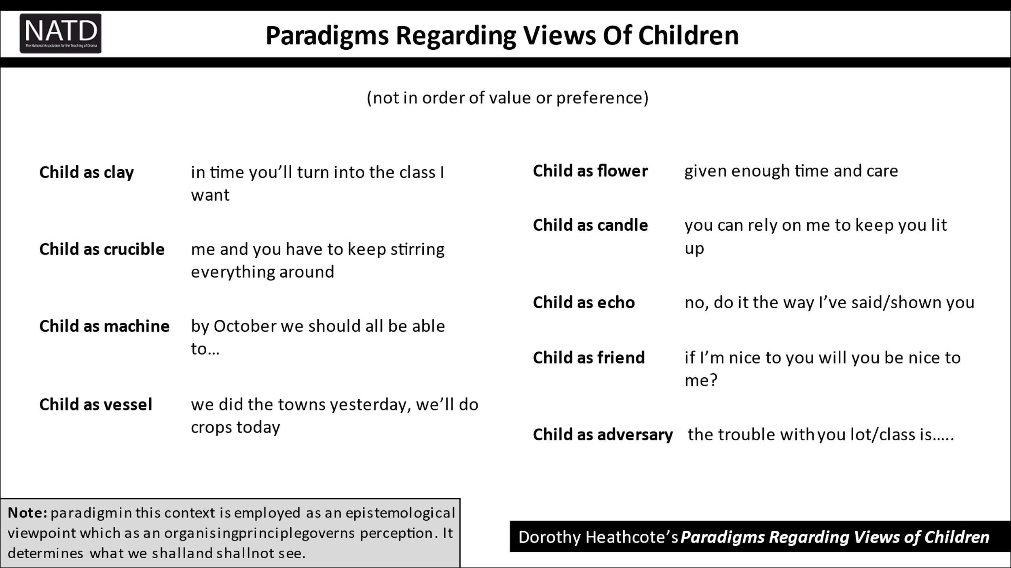

Those present determined that, largely, the assessment system currently views the child as a combination of machine (‘by the end of a two year course, students should be able to prove their worth in a two hour exam’) and vessel (‘students should be able to recall the knowledge they have gained from their long term memory’).

As the effects of attrition have set in throughout this pandemic, I have often found myself checking in with this model, considering how the decisions made as Head of Department represent my view of the young people I teach. Asking children to remain in their socially distanced boxes outlined on the studio floor and limiting their contact with one another felt like a necessary evil at the height of the pandemic. But what view does that present of the child? Writing a recovery curriculum plan that prioritises catching up on Brecht and Stanislavski to get them through their exam, rather than spending time developing their ability to create drama collaboratively: what view does that present of the child? Returning to an assessment system that reduces intellectual curiosity, creative collaboration, personal triumph, perseverance, empathy and resilience to a number on a piece of paper rather than attempting to capture the nuance of each child’s personal development what view might this present of the child?

It is a question I charge us all to ponder carefully as we enter into the next phase of this pandemic. And the question is an urgent one for the young people living through it.

The Journal for Drama in Education Vol 19 Issue 1
National Association for the Teaching of Drama
Signs (and Portents?) Dorothy Heathcote SCYPT Journal 9, 1982

