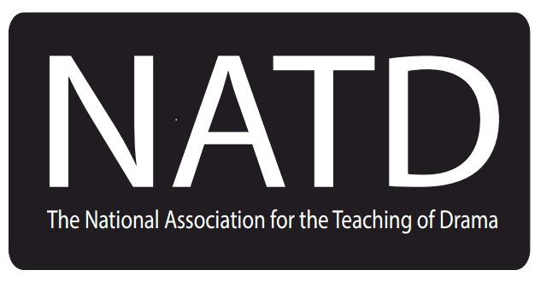For Members of NATD - Sponsorship Offer
We are offering to sponsor a teacher to attend the Dorothy Heathcote Now International Drama Conference 2023.*

The conference will take place in Aberdeen, Scotland from 09:00 on Thursday 5th October 2023 to 17:00 on Sunday 8th October 2023.

The sponsorship will cover the conference fees only. Travel and accommodation costs will not be covered.

If you are in your first 5 years of teaching, are currently teaching in the UK and would like to apply please complete the application form to be found at natd.co.uk.

Closing date for applications: 9th July.
*https://dorothy-heathcote-now-2023.eventbrite.co.uk

Name: | How long have you been a member of NATD?:
Do you intend to attend the whole conference? | If not, which two days would you like to attend?
If you do intend to attend the whole conference, do you have permission from your school to take that time off?

Outline in a few sentences how you have already tried to use Dorothy Heathcote’s work in your daily class teaching.

Outline in a few sentences how you aim to further incorporate the work of Dorothy Heathcote in your practice.

Please return the completed form by 9th July 2023 to maggie.hulson@yahoo.co.uk.

